- Firstly, download WinAuth from this link:
https://github.com/winauth/winauth/releases/download/3.5.1/WinAuth-3.5.1.zip.
- Open the downloaded zip file and drag the WinAuth application to your desktop.
- Double-click the new WinAuth icon you just created.

- Click the Add button, then select the top Authenticator option from the drop-down menu and type an appropriate name, such as the account name, e.g. john.smith@myschool.norfolk.sch.uk.
- Go to https://www.office.com/ and click the Sign in button. Enter your username and click Next, then enter your password and click Sign in.
- When prompted with “More information required”, click Next.

At this point there are two possible sets of steps, depending on your school’s security settings.

If the next screen is headed with “Keep your account secure”, follow these steps below:
- Click the blue link “I want to use a different authenticator app”.

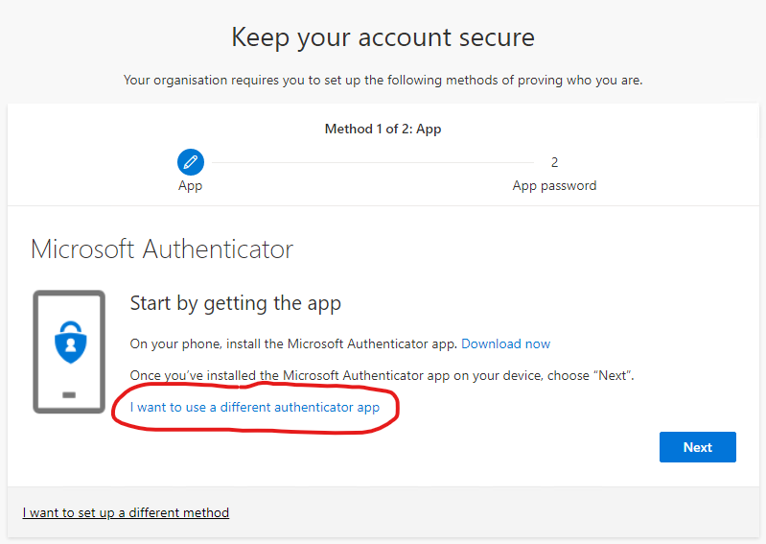
- Click Next, then click the “Can’t scan image?” button under the QR code.
- Click the small icon next to the “Secret key” to copy it to your clipboard.
- Return to WinAuth and paste this into the box under section 1, then click Verify Authenticator under section 3.
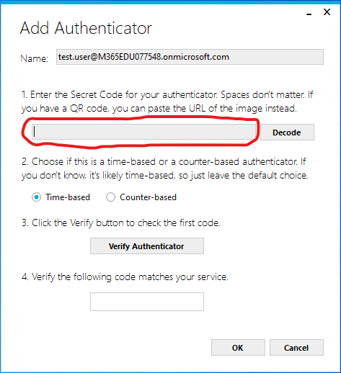
- Back on the website, click Next and type the 6-digit number from WinAuth into the “Enter code” box. Click Next again.
- You may next be prompted to create an “App password”. This is not required in most cases, so either type a minimum of 8 characters into the box provided and click Next, or just close your browser.
- Back in WinAuth, click the OK button at the bottom of the window to save your first account.

If the next screen is headed with “Additional security verification”, follow these steps below:
- On Step 1, select “Mobile app” from the drop-down menu, and select the “Use verification code” radio button. Then click Set up.
- Click the link that says “Configure app without notifications”.
- Select the text after “Secret Key:” (there should be 16 random letters plus spaces), right-click and select Copy.
- Return to WinAuth and paste this into the box under section 1, then click Verify Authenticator under section 3.
- Back on the website, click Next, then Next again.
- On Step 2, type the 6-digit number from WinAuth section 4 into the textbox and click Verify.
- On Step 3, select United Kingdom from the drop-down menu and enter your mobile number in the textbox, then click Next.
- If Step 4 appears showing an “app password”, this is not required in most cases, so can be ignored. Click Done to finish.
- Back in WinAuth, click the OK button at the bottom of the window to save your first account.

Once you have completed one of the above sets of steps, uncheck the “Protect with my own password” checkbox, and check the “Encrypt to only be useable on this computer” and “And only by the current user on this computer" checkboxes, then click OK.

In future, when prompted for an MFA code during sign in, just open WinAuth, click the large “refresh” icon to the right of the account you wish to sign in to, then type the code shown into the box provided. If there is an option stating “Don't ask again for XX days” and you are not using a shared computer/device, you can check the box to avoid having to re-enter an MFA code every time you sign in. The same applies if you are then prompted to “Stay signed in?”.

